Creating lifetime memories
We all remember the first time we sleep away from home and the 1st Wellesbourne Rainbows enjoyed a fun packed programme at their recent sleepover on the 26th May at Rowington village hall. The girls aged 5 – 7 years, chose a number of science themed activities on the Saturday afternoon which included making climbing spiders, bunny helicopters, rocket paper mice, chromatography butterflies and then they helped to make their evening meal. For pudding the chocolate fountain was a huge success – dipping a variety of fresh fruit and marshmallows.
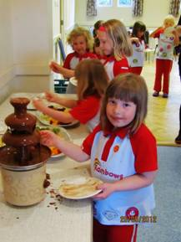
Rosie enjoying the chocolate fountain
This was followed by singing and dancing, then one of the leaders made her promise by candlelight before it was time to make the beds and have cocoa with story time. Lights out was at 9.00pm, when the traditional mid-night feasts began! Most of the girls were fast asleep by 10.30pm, with the last few holding out till midnight.
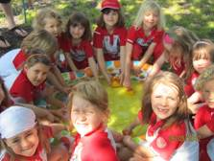Rainbows at the duck pond
After having breakfast we packed our beds away on the Sunday morning. We were lucky to have another warm, sunny day - giving us the opportunity to do some marble art outside followed by a nature detective hunt,
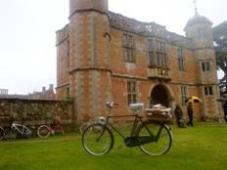
Charlecote Park

Diamond Jubilee weather did not deter cyclists who arrived at Charlecote Park on Sunday 3rd June on for a special trip on Pashley cycles of many types and colours. Also present to mark to occasion was the Bedworth Wind Band. Although not a good day for picnics, the cook in the Victorian Kitchen was making soup, while children were kneading dough and making drop scones.
Everyone will now be watching to see the first of the young deer moving around the park, while the lambs are already looking more like sheep.
It is never too late to claim your free Charlecote Pass. If you are a Wellesbourne resident simply leave a SAE envelope at the library with a note of how many members of your household need a pass.
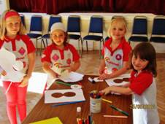
Melissa, Hannah, Alex and Megan having fun with the science activities
hook a duck, a listening walk, parachute games and a picnic At the normal meeting the following Wednesday evening we had our Jubilee celebrations, making jewelled crowns and having a joint tea party with the Brownies.
If your daughter would like to join Rainbows and be part of the fun this can bring, then contact Kate Skinner on 01789 842148 to add her name to the waiting list. We are also keen to hear from anyone who is interested in volunteering with Rainbows, Brownies or Guides; again contact Kate for more information.
Sunflower
(leader's name)
Alison Bollons –1st Wellesbourne Rainbows Leader-in-training

July will see school holiday events starting with “Cuddly Critters” for children to spot in the house. Special children’s events are planned throughout August. On Sunday 22 July Heartbreak Productions are returning to the Park with “The Railway Children”. Details are available at www.heartbreakproductions.co.uk or tickets can be purchased on 0844 249 1895.
From the end of July through August the house is open from 11 to 4.30 every day except Wednesday, and the park daily. The restaurant has full meal service and is open until 5pm daily.
On Saturday 28th July there will be a “Walk with the Gardener” (normal admission charges only).

.Tailpiece
Bert was concerned that his wife Peg wasn't hearing as well as she used to and he thought she might need a hearing aid. Not being quite sure how to approach the subject he called the family doctor to discuss the problem.
The doctor told him of a simple informal test he could perform to give him a better idea about her hearing loss.
“Stand about 40 feet away from her,” said the doctor, “and in a normal speaking tone see if she hears you. If not, go to 30 feet, then 20 feet and so on until you get a response.”
That evening, as his wife was in the kitchen cooking dinner, and he was in the sitting room he thought, “I'm about 40 feet away, let's see what happens.” Then in a normal tone he asked, “What's for dinner this evening dear?”
There was no answer.
So he moved closer, to about 30 feet from his wife and repeated, “Peg, what's for dinner?'
Still there was no reply.
So he moved even closer until he’s only 20 feet away and asked again, “What’s for dinner, my love?”
Again there was no response.
So, he walked up to the kitchen door, about 10 feet away and tried again, “Darling, what’s for dinner tonight?”
Once more there was no answer.
So he walked right up behind her and asked again, “Peg, dear, what's for dinner?'
“For Pete’s sake, Bert, for the FIFTH time, CHICKEN!”

