‘Choir of Survivors’

On Sunday 20th May, a new statue was unveiled in the Coventry Cathedral Ruins. The statue titled ‘Choir of Survivors’ was dedicated to civilians killed or injured in aerial bombing during wars past and present. During the act of dedication specific reference was made to German civilians killed in the allied bombings in 1940-1945.
The ceremony was part of the 50th Anniversary events which commemorates not only the work of the Peace and Reconciliation Ministry during the past five decades but looking towards the future as the Ruins are rededicated to be a permanent memorial to civilians killed, injured or traumatised by war and violent conflict.
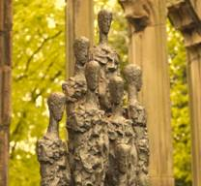
'Choir of Survivors' Statue,
a gift from our friends at the Frauenkirche in Dresden
The statue, created by German Sculptor Helmut Heinze, is the first permanent memorial to German civilians within the grounds of Coventry Cathedral.
"An important part of our anniversary is not only to celebrate the past 50 years and the work in Peace and Reconciliation, but also to look forward to the future and to provide a safe space, a haven to remember those civilians killed or injured in wars across the globe," commented the Very Reverend John Irvine, Dean of Coventry. "When my predecessor, Provost Howard, had the words ‘Father Forgive’ placed on the Ruins, it was not focused just at our enemies but on us all for the actions and impact of war."
"Reconciliation can be said to have truly happened when we are able to memorialise the suffering of our enemies," continued David Porter, Canon Director for Peace and Reconciliation, "This is a significant event in Coventry’s story of Peace and Reconciliation and will enable us to talk not only of the night of 14th November 1940 and how the people of Coventry coped with the aftermath, but also of the suffering of other cities, towns and communities across the world."
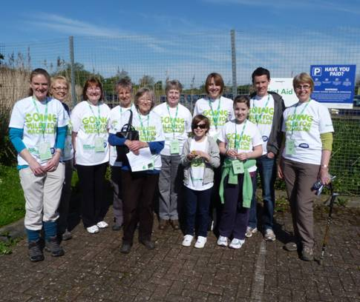
MACMILLAN CANCER SUPPORT
Members of the Wellesbourne Committee took part in the Hatton Canal Walk on Sunday 13th May. We were very lucky with the weather - the sun shone - and we completed the 7 mile walk in good time. The team raised the fantastic amount of £681.00
Thank you to all who kindly sponsored us for the event.

Bringing Superfast broadband to WELLESBOURNE

The internet is becoming increasingly important in modern home life, from free of charge face to face conversations via Skype, watching films and TV programmes on line, to working from home and online learning for students. Unfortunately however, many homes in our area do not have the ability to connect to fast and reliable internet connects. With your help this can change!
In Wellesbourne, many streets can now get speeds of up to 17Mps, but others still only get 4Mps; why should we not all have access to Superfast Broadband at 24Mps?
Warwickshire County Council is leading on the project to improve the broadband across the sub-region and they need your help. Just over £8m is available from central and local government for the provision of superfast broadband (24Mbps or more) in Coventry, Solihull and Warwickshire. Clearly the money available from public funds will not be sufficient to solve the problem for the whole sub-region, and so telecoms providers who tender for the work will be expected to make their own significant investment.
They will not be doing this out of the goodness of their hearts, and so are likely to prioritise those areas where we are able to provide the most compelling business case by illustrating the demand for superfast broadband in the area.

What can you do to help?
Complete the Residents and/or Business Surveys
If you have not already done so please complete the broadband survey that is located at http://www.cswbroadband.org.uk/ - there is one survey for domestic use and one for business use, so if you run a business or work from home please do both. Encourage your neighbours to do it as well because the more people that respond from a given area the higher priority it will be. If you experience any difficulty in completing the survey please email broadband@warwickshire.gov.uk. Please complete your surveys as soon as possible and before the end of July.
Your assistance could make all the difference to Wellesbourne getting superfast broadband!
Poetic Phrases
The ballerina rose gracefully en pointe and extended one slender leg behind her, like a dog at a lamppost.
He was deeply in love. When she spoke, he thought he heard bells, as if she were a dustcart reversing.
She walked into my office like a centipede with 98 missing legs.

