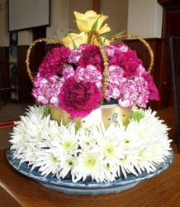
Margaret’s Jubilee arrangement
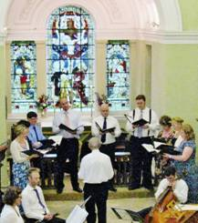
The Coten Musicians at Walton Concert
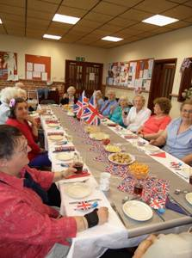
Lunch at the Methodist “non-street Party”
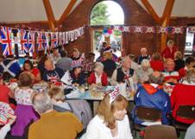
Chapel Street & Garden Terrace indoor party
JUBILEE

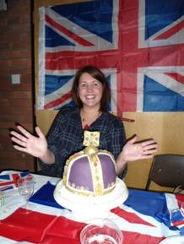
Hannah and the Jubilee Crown Cake
“Do the Queen proud,” was the Lord Lieutenant’s call to the WI at Stoneleigh and, in spite of the weather, Wellesbourne did just that.
The highlight of the weekend was undoubtedly the lighting of the Jubilee Beacon watched from all over the village many having first attended a most excellent barbecue to put them in the mood. The flame was greeted with a huge round of spontaneous applause as the wind blew it dramatically across the tower. A difficult subject to photograph but our Clerk to the Council, Lynda, captured the moment for the front page.
Various street parties were hurriedly relocated under cover with the Church Centre being a popular venue. Sycamore Close were one of the few to defeat the storm clouds holding theirs at lunchtime instead. Many barbecues were pressed into service and many chefs braved the elements, there was music galore, with much pomp and circumstance patriotically bawled out with great enthusiasm. The Union Jack was much in evidence with crockery, hats and waistcoats and undoubtedly other patriotic clothing not on outward display
And always there was cake! From the Jubilee Cream Teas & Songs of Praise to the final glorious Jubilee Concert by the Coten Singers and Ensemble at Walton, there was always cake. Some magnificent creations and equally tasty too. I loved ’em.
I think Wellesbourne did HM proud.
By the way, isn’t next June the 60th anniversary of the Coronation?
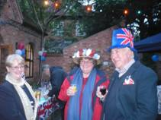
Waiting for the Beacon to be lit
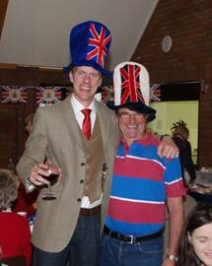
Patriotic hats
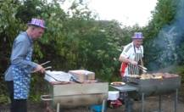
Men don’t do multi-tasking
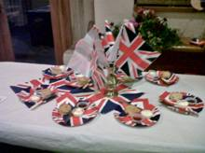
Patriotic dishes
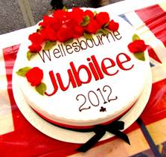
Jubilee cake at Sycamore Close

