Spotlight on -
THE PARISH COUNCIL


Cllr. Mrs. Rosalind Bolton Tel 840814 (Vice Chairman)
19 Kineton Road, Wellesbourne

Cllr. Eric Lawley Tel: 555678
5 Debden Close, Wellesbourne

Cllr Geoff Rose Tel 840672
22 Grange Gardens, Wellesbourne

Cllr. Danny Kendall Tel 842577
3 Gloster Gardens. Wellesbourne
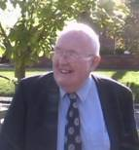
Cllr. John Grantham Tel 840449
10 Church Street Wellesbourne

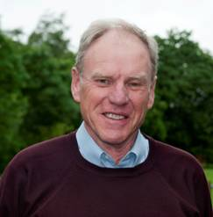
Cllr. David Close (Chairman) Tel 840302
24 Brookside Avenue, Wellesbourne
In May the village elected its eleven Parish Councillors. This time the council has four completely new members which is more than we have had at any one time for many years.
In addition to the more routine matters such as advising on planning applications, keeping the playing fields in a clean and good condition, reporting highways matters the council will be working on the development of the sports club, advising on the planning details for the 175 houses on the Redhill site and considering whether to purchase the Village Hall and the car park.
The Council will shortly be seeking a new voluntary administrator for the website, should you have any expertise and would be interested please contact the Clerk with your details.
To remind you, the Parish Council Office can be visited in person at the following times -
Monday/Tues/Wed 2.00pm – 4.30pm
Thurs/Fri 9.15am – 12.15pm
Telephone contact on 01789 841434 can also be made during office hours (Monday - Friday 9.00am - 5.00pm) when one of the staff usually can personally take your call. At all other times a recorded message can be left.
Meetings for July are
3rd July - Full Council Meeting – Methodist Hall, Bridge Street– 7.30pm
24th July - Amenities Meeting – Parish Council Office, School Road – 7.30pm
David Close
Chairman

Mrs Julia Lipman Mrs Lynda Scriven
Admin Assistant Clerk/RFO
Office: 2 School Road Tel 841434


Cllr. Mrs. Anne Prior Tel 842103
7 Wyvern Close, Wellesbourne

Cllr. Mike Podbury Tel 841147
47 Kineton Rd, Wellesbourne

Cllr. Ian Rutherford Tel 840369
5 Chestnut Sq., Wellesbourne

Cllr Mrs Val Bartlett Tel 840656
Beechwood House, 3 Walton

Cllr. Alan Shepherd Tel 841332
6 Charlecote Fields, Wellesb’ne

