Jo Ognjanovic
I am really looking forward to meeting you all in Wellesbourne and Walton D’Eivile this summer when I join you as curate.
Just to introduce myself briefly; I am married to Rade (my wonderful husband of 19 years) and we have two busy, active, bright children, Abi (15) and Isaac (13) of whom (can you tell?) I am very proud. My hobbies include painting and drawing, gardening, reading and family caravan holidays.

Before becoming a Christian 11 years ago I worked in a hospital laboratory diagnosing infections. I have also worked in childcare and been self-employed as a book seller and portrait artist among many other things!
I trained and ministered full-time as a Reader in Southam before undertaking my ordination training at St Mellitus College in London. I am currently engaged in some voluntary work with vulnerable women caught in prostitution in Coventry and hope to discover what God might be up to in Coventry city centre for the other part of my time during the next few years.
My passion is for Jesus, as I attempt to follow his call on my life, for all sorts of people and for bringing the two closer together. I am excited about being welcomed into a new community and about getting to know you. Please be assured of my prayers for you all and do please stop me for a chat!

Wellesbourne & District Lions
A big thank you goes to everyone who supported the jubilee fun day at Loxley Fox
On Monday 3rd June, after a full day of Britain’s finest precipitation on the Sunday, we were blessed with the best weather of the long weekend. Everybody seemed to enjoy the day with many staying on for the evening to be entertained by excellent local band ‘Cactus Jam’. Takings for the day are still being reconciled and I will report total funds raised in a later newsletter.
We are coming up to the summer fair season and Wellesbourne Lions are pleased to have been invited to Barford fete on Saturday 7th July and Walton fete on Sunday 29th July. We hope you will be able to come along to one or both of these annual events and we look forward to meeting you there.
As I write I am wondering whether the annual raft race will be going ahead as the awful summer continues. Hopefully I will be able to tell you all about it in the next newsletter.
Lion Andy Stokes
Dene Valley u3a
Iam writing this before the meeting on 12th. June and I am looking forward to the talk about Cordelia Leigh who kept a war diary which is today held at the Stratford Record Office. Next month on 10th July, the talk is called: “The curious story of the diary in the attic.” Sounds interesting.
The outing recently to Adam Henson’s Cotswold Farm Park and the Gloucs/Warwicks Railway was a great success. A new outing is planned for December to the Malvern Theatre to see Cinderella along with visits to the Ludlow Food and Drink Festival in September and Lichfield in October.
Our featured groups this month are the physical activity ones. We run two Pilates groups, a Fun exercise group, Tai Chi, Strictly u3a, and Walking. The walking group are going to Wroxton on 20th. June for a walk, finishing at a pub or tea room.
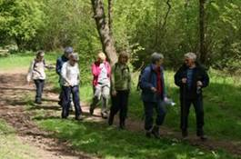
Our walking group on their last outing.
We run many other interest groups covering a huge range of activities. We hope you will join us and see what we offer. Come along to our monthly meeting to begin with. You get an interesting talk, a cup of tea or coffee with biscuits and gather information about our activities.
Contact our chairman for more information: Dick Prior 01789 842103 or visit our website: www.denevalleyu3a.btck.co.uk
Anne Prior Group coordinator

A First for Wellesbourne?
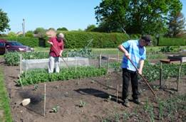
Down at the allotments everyone is busy. On Sunday July 15th from 2 – 5 pm Wellesbourne Allotments in Kineton Road are opening under the National Gardens Scheme, and will be raising money as well as plants this year. There will be a chance to see all manner of crops and flowers, delicious new potatoes, peas and carrots. Mouth-watering strawberries are also ripening with so many other fruits not far behind. It truly is a season of plenty! The experts will be on hand to discuss the finer points of how it can be done and to explain the best watering systems, in the event of lack of rain. There will be refreshments, plants and produce on sale and a chance to help judge the best scarecrow.
WELLESBOURNE CofE PRIMARY SCHOOL
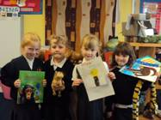
What have we been learning about in Wellesbourne School?
At Wellesbourne CE Primary School we aim to engage the children 100% in their own learning. In Year 1 we encourage our children to think about what they already know and what they would like to find out about next. This term we have been finding out how our lives in Wellesbourne compare to those in an African Village. We had lots of fun creating an African Market in our classroom.
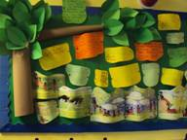
We learnt a welcoming Swahili song called 'A Keelie'. We drew maps and keys of places in Kenya and Wellesbourne, made our own safari maths word problems, and wrote our own rhyming safari stories. We also wrote and played our own musical compositions for African songs. We all agreed in Year 1 there has been LOTS of LEARNING & LOTS of FUN!
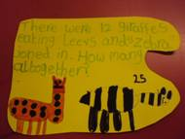
If you would like to find out more about Wellesbourne CE Primary School please contact Mrs Price or Mrs Oram in the school office on 01789 840311
